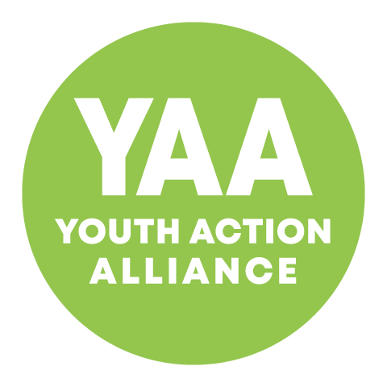 | Membership & Consent Form | Views no: ______
Project:
_____________________
Activity:
_____________________
Please complete clearly in ALL CAPITAL letters.

PARTICIPANT DETAILS

First Name: |  |  | Surname:
Date of Birth: |  |  | Age:
Gender: | ⬜ Male ⬜ Female ⬜ Other __________ ⬜ Prefer not to say
Home Address:
Postal Code: |  |  | Email:
Tel/Mobile No:
School/College attended:

Ethnicity:
⬜ Black African | ⬜ Indian | ⬜ Chinese | ⬜ White & Black Caribbean
⬜ Black Caribbean | ⬜ Pakistani | ⬜ White (UK) | ⬜ White & Black African
⬜ Black Other | ⬜ Bangladeshi | ⬜ White (Irish) | ⬜ White & Asian
⬜ Moroccan | ⬜ Asian Other | ⬜ White (Other) | ⬜ Other Mixed
⬜ I do not wish to give the information |  | ⬜ Unspecified /Other

HEALTH & WELLBEING

Indicate below if your child has an illness or injury which might affect them whilst attending YAA:

⬜ Special Education Needs/LLDD ⬜ Epilepsy ⬜ Asthma ⬜ Diabetes ⬜ Allergies
⬜ Other: ___________________________________________________________________
Dietary requirements: (i.e halal, vegetarian) _______________________________________

Please indicate if your child takes any medication:
*This does not indicate that we are taking responsibility for the giving of medicine; it is only for information regarding your child’s ability to participate in the activities.
Medication:
Name of Doctor: |  | Telephone No:

EMERGENCY CONTACT

Full Name:
Address:
Telephone No:
Email Address:

PHOTOGRAPHY/ VIDEO CONSENT (for children and young people under 18)
Youth Action Alliance would like to take photography/webcam recordings of your child or dependent participating in YAA activities/sessions. These images/recordings may appear in our printed publications, our website and social media, to promote our services. To comply with the Data Protection Act 2018, we need your permission. We will not publicize any personal data without your full consent. You can withdraw consent at any point by contacting us at info@youthactionalliance.org
or 020 8964 3149.

May we use images/recordings of your child for promotional purposes? ⬜ Yes ⬜ No

PARENTAL CONSENT

I, the undersigned, have read and understood the purpose of the above information and conditions of this form, and give my consent (for my child) to participate in YAA activities.
If you are under 18 years old, a parent/guardian must sign this form.

Name of Parent/Carer:
If different from emergency contact details:
Address:
Telephone No:
Email Address:
Signature:

Date:

